The Routemaster returns to Slough!
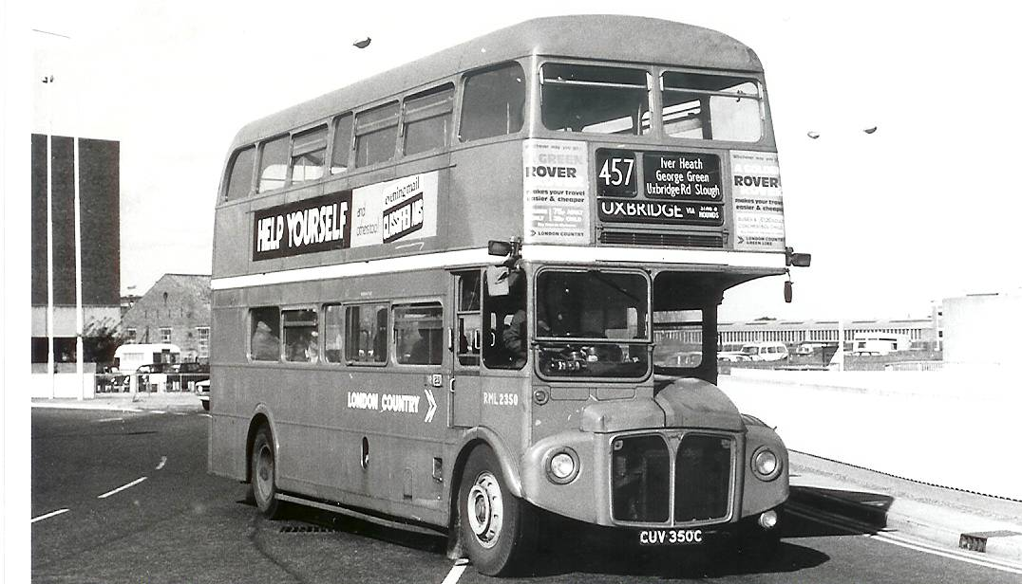

This photo was taken by Steve Fennell in the 1970s when green Routemasters were to be seen on many routes locally.

On Sunday 14 May 2006 Routemasters will once more grace the streets of Slough and Windsor. Some 40 years earlier, on 15 May 1966, new Routemasters were allocated to Windsor Garage to serve, amongst others, Slough local routes 446,446A and 446B which plied between Slough Station and Farnham Road or the Trading Estate via Whitby Road, Manor Park or Bath Road.

In 2006 they will be operating a number of routes primarily Route 441 between High Wycombe & Windsor, 457 between Uxbridge & Windsor – both these routes serving Slough and 474 between Slough & Burnham Beeches, a route withdrawn in 1957.

They will also be appearing on other routes alongside buses which are even older. It is hoped a single decker dating from 1938 will also be in service as well as several dating from the 1950s.

159 departures are scheduled from Slough Bus Station to a wide range of destinations making it a great day out for people of all ages.

All are welcome to come along but please respect the vehicles you are travelling on. Please refrain from smoking, eating and drinking on the buses. The owners have spent a good deal of their own money to restore the vehicles and it is at their discretion that you can travel.

You may wish to go shopping in Slough, stroll through Burnham Beeches, watch the Fun Run at Gerrards Cross or explore Windsor Great Park …………..there is something for YOU! Please come along – first bus 09.50 last bus 17.37.

Programmes including detailed timetables are now on sale for the Slough/Windsor event.

They cost £5 each and are available to personal callers from:

Enquiry Office, Slough Bus Station, Brunel Way, SLOUGH

Tourist Information Office, Pauls Row, HIGH WYCOMBE

Or by post @ £5 from:

Peter Cartwright, 54 Guinions Road, HIGH WYCOMBE HP13 7NX.
Cheques payable to Amersham & District Motorbus Society.

Or on the day itself from a stall within the Bus Station.

To make the most of your day please obtain a programme in advance. Remember, fares will not be charged on the services shown in the timetables.

